1. Creating and Renaming Files/Directories
Create a directory named test_dir using mkdir.
=>mkdir test_dir
Inside test_dir, create an empty file called example.txt.
=>cd test_dir
=>touch example.txt
Rename example.txt to renamed_example.txt using mv
=>mv example.txt renamed_example.txt
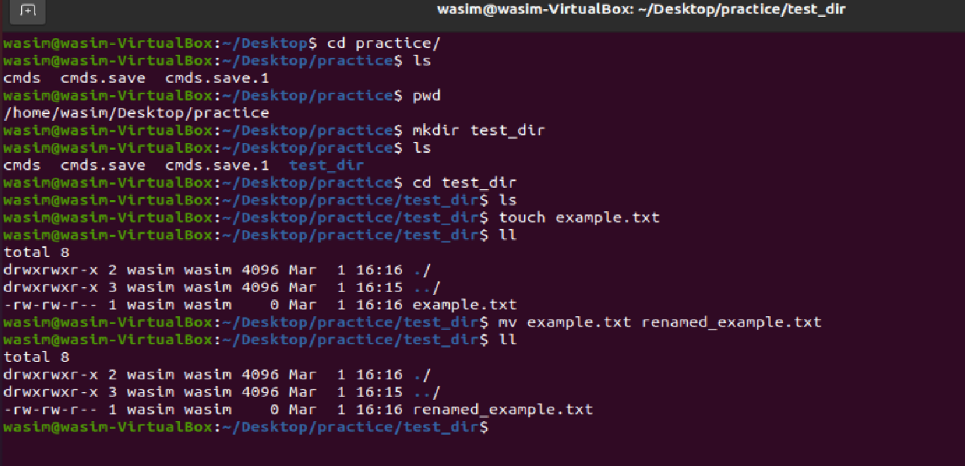
2. Viewing File Contents
Use cat to display the contents of /etc/passwd.
=>cat /etc/passwd
Display only the first 5 lines of /etc/passwd using head.
=>head -n 5 /etc/passwd
Display only the last 5 lines of /etc/passwd using tail.
=>tail -n 5 /etc/passwd
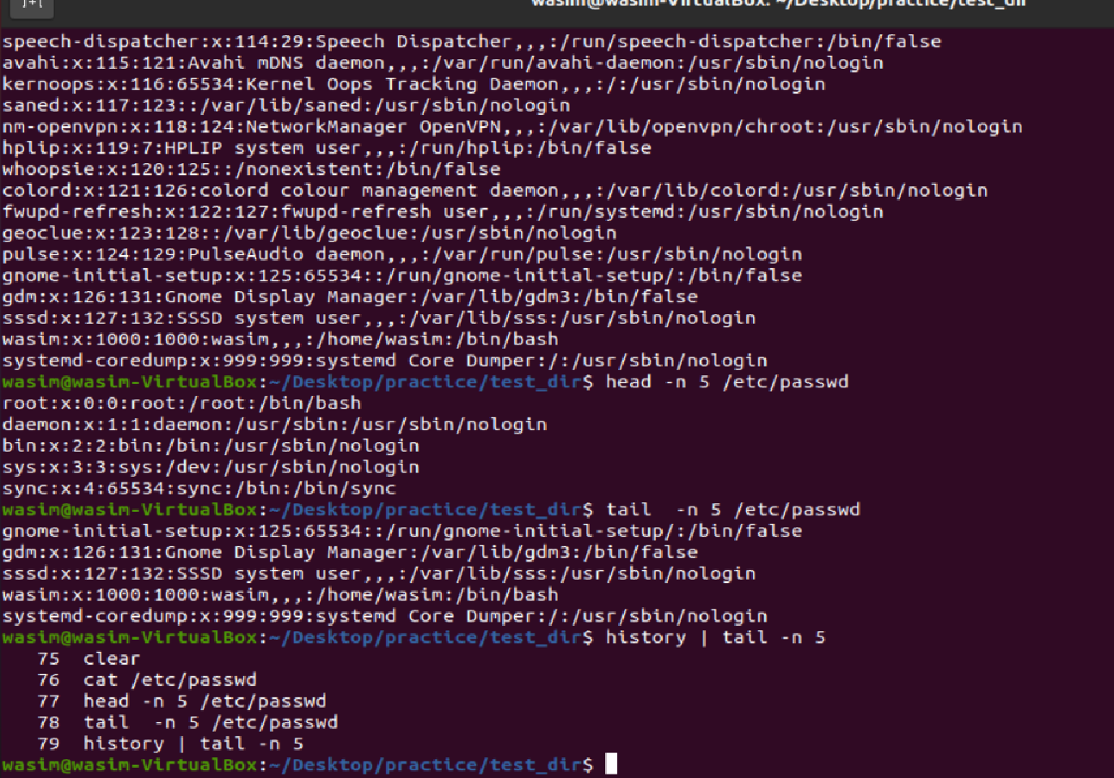

3.Searching for Patterns
Use grep to find all lines containing the word "root" in /etc/passwd.
=>cat /etc/passwd | grep root
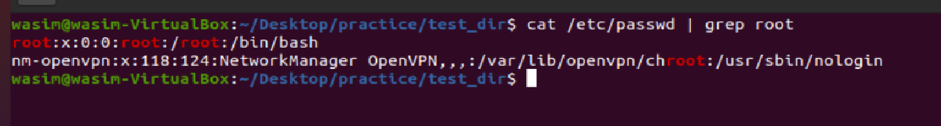
4. Zipping and Unzipping
Compress the test_dir directory into a file named test_dir.zip using zip.
=> zip -r test_dir.zip test_dir/
Unzip test_dir.zip into a new directory named unzipped_dir.
=> unzip test_dir.zip -d unzipped_dir/
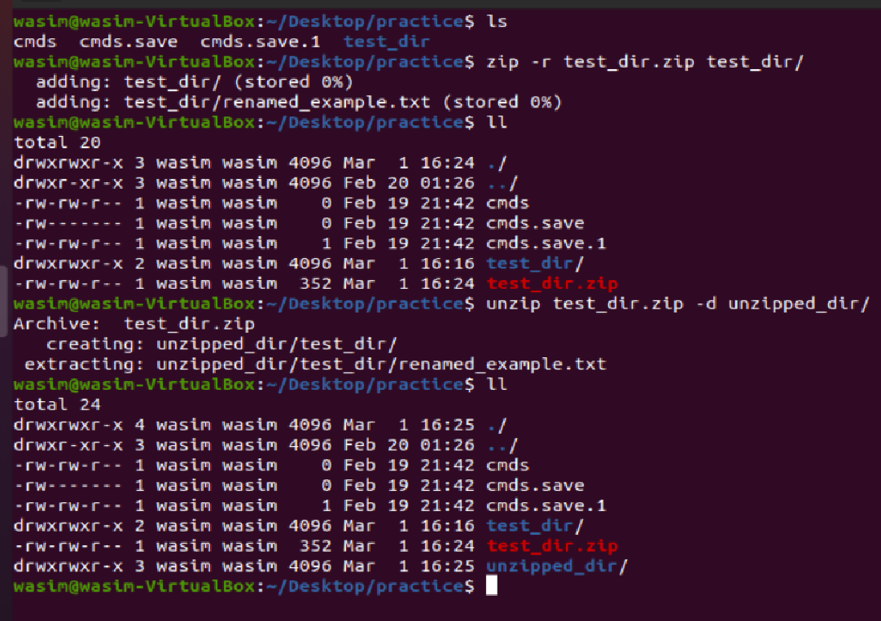
5. Downloading Files
Use wget to download a file from a URL (e.g., https://example.com/sample.txt).
=>wget raw.githubusercontent.com/Wasim24/Linux-assignment/refs/heads/main/linux
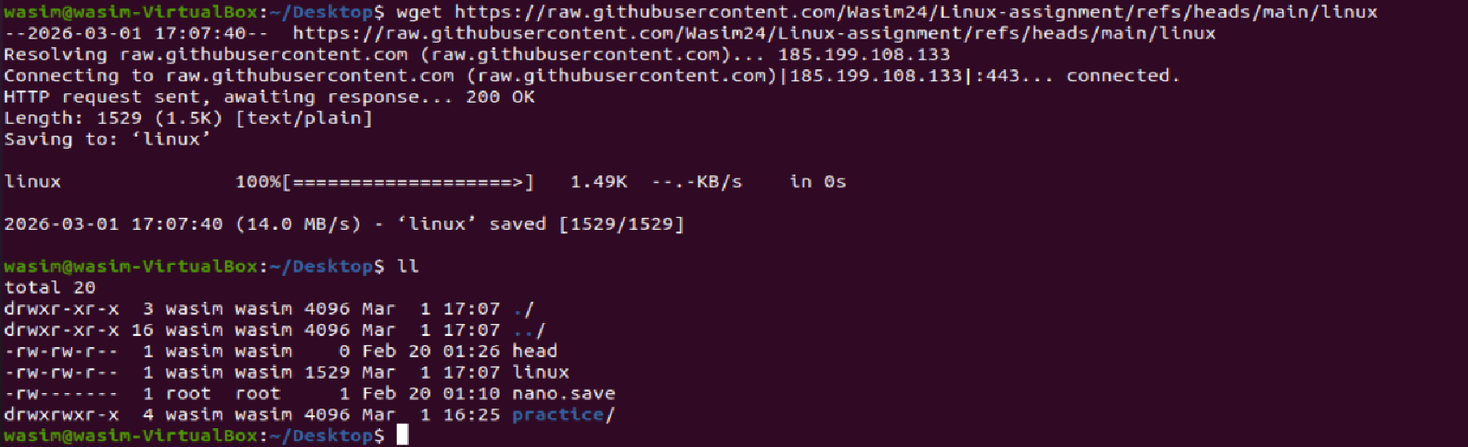
6. Changing Permissions
Create a file named secure.txt and change its permissions to read-only for everyone using chmod.
=> chmod 444 secure.txt
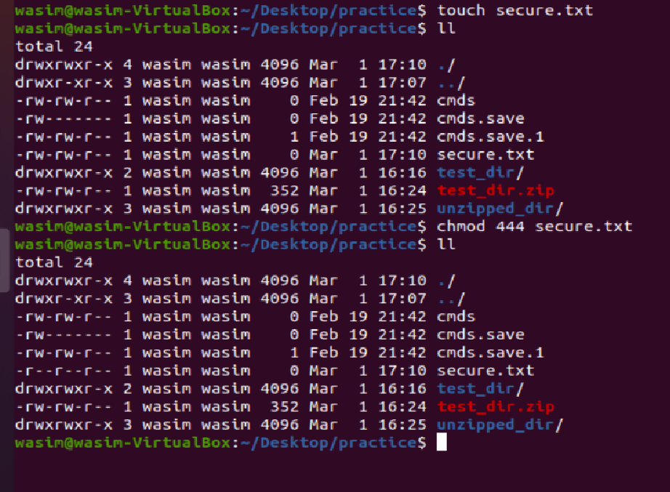

7. Working with Environment Variables
Use export to set a new environment variable called MY_VAR with the value "Hello, Linux!".
=>export MY_VAR=”Hello, Linux”
=>echo $MY_VAR
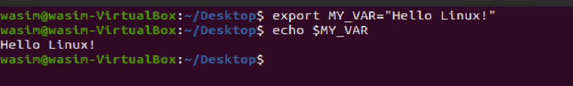
Submission Guidelines -: Attach Screenshots or command along with explanation and submit in doc(google doc or microsoft doc) format also attach github repo link

